21.76: a) 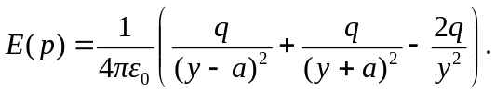
b) 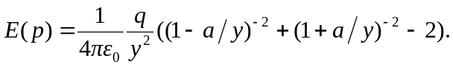 Using the binomial expansion:
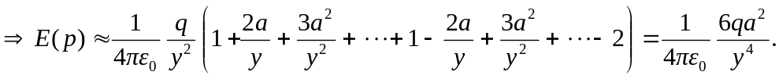
Note that a point charge drops off like 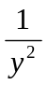 and a dipole like 